# Assignment - 4

**LSTM for Text Classification**

|  |  |
| --- | --- |
| Assignment submission | 03 November 2022 |
| Student Name | Raja Shelshita A |
| Student Roll Number | 951919CS078 |
| Maximum Marks | 2 Marks |

# Download the Dataset

1. **Import required library**

import pandas as pd import numpy as np

import matplotlib.pyplot as plt import seaborn as sns

from sklearn.model_selection import train_test_split from sklearn.preprocessing import LabelEncoder from keras.models import Model

from keras.layers import LSTM, Activation, Dense, Dropout, Input, Embedding from keras.optimizers import RMSprop

from keras.preprocessing.text import Tokenizer from keras.utils import pad_sequences

from keras.utils import to_categorical from keras.callbacks import EarlyStopping

%matplotlib inline

# Read dataset and do pre-processing

Load the data into Pandas dataframe

df = pd.read_csv('/content/spam.csv',delimiter=',',encoding='latin-1') df.head()

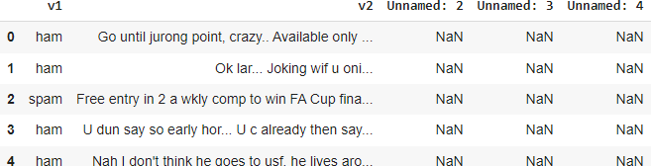

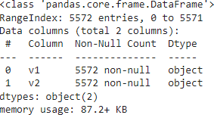Drop the columns that are not required for the neural network. df.drop(['Unnamed: 2', 'Unnamed: 3', 'Unnamed: 4'],axis=1,inplace=True) df.info()

Understand the distribution better.

sns.countplot(df.v1) plt.xlabel('Label')

plt.title('Number of ham and spam messages')

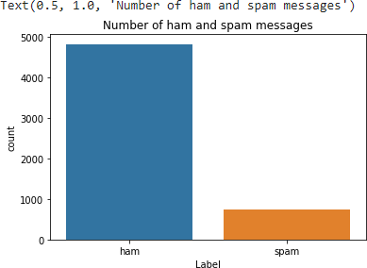

* Create input and output vectors.
* Process the labels.

X = df.v2 Y = df.v1

le = LabelEncoder()

Y = le.fit_transform(Y) Y = Y.reshape(-1,1)

Split into training and test data.

X_train,X_test,Y_train,Y_test = train_test_split(X,Y,test_size=0.15)

Process the data

* Tokenize the data and convert the text to sequences.
* Add padding to ensure that all the sequences have the same shape.
* There are many ways of taking the *max_len* and here an arbitrary length of 150 is chosen.

max_words = 1000

max_len = 150

tok = Tokenizer(num_words=max_words) tok.fit_on_texts(X_train)

sequences = tok.texts_to_sequences(X_train)

sequences_matrix =pad_sequences(sequences,maxlen=max_len)

# Create Model

* **Add Layers (LSTM, Dense-(Hidden Layers), Output)**

Define the RNN structure. def RNN():

inputs = Input(name='inputs',shape=[max_len])

layer = Embedding(max_words,50,input_length=max_len)(inputs) layer = LSTM(64)(layer)

layer = Dense(256,name='FC1')(layer) layer = Activation('relu')(layer)

layer = Dropout(0.5)(layer)

layer = Dense(1,name='out_layer')(layer) layer = Activation('sigmoid')(layer)

model = Model(inputs=inputs,outputs=layer) return model

Call the function and compile the model. model = RNN()

model.summary()

# Compile the Model

model.compile(loss='binary_crossentropy',optimizer=RMSprop(),metrics=['accuracy'])

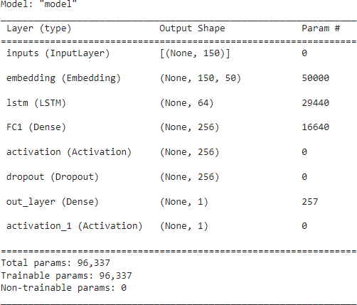

# Fit the Model

model.fit(sequences_matrix,Y_train,batch_size=128,epochs=10, validation_split=0.2,callbacks=[EarlyStopping(monitor='val_loss',min_delta=0.0001)])

The model performs well on the validation set and this configuration is chosen as the final model.

# Save The Model

lstm_model.save('text_model.h5')

# Test The Model

test_sequences = tok.texts_to_sequences(X_test)

test_sequences_matrix =pad_sequences(test_sequences,maxlen=max_len) Evaluate the model on the test set.

accr = model.evaluate(test_sequences_matrix,Y_test)



print('Test set\n Loss: {:0.3f}\n Accuracy: {:0.3f}'.format(accr[0],accr[1]))

